PHP Xdebug

Aug 29, 2022
Xdebug is an extension for PHP, and provides a range of features to improve the PHP development experience.

Install
For Fedora:
dnf install php-pecl-xdebug3-3.1.5-1.fc36.x86_64

In /etc/php.d/15-xdebug.ini
xdebug.mode = develop,debug,profile,trace

Feautures

Step Debugging
A way to step through your code in your IDE or editor while the script is executing.
Improvements to PHP's error reporting
An improved var_dump() function, stack traces for Notices, Warnings, Errors and Exceptions to highlight the code path to the error
Tracing
Writes every function call, with arguments and invocation location to disk. Optionally also includes every variable assignment and return value for each function.
Profiling
Allows you, with the help of visualisation tools, to analyse the performance of your PHP application and find bottlenecks.
Code Coverage Analysis
To show which parts of your code base are executed when running unit tests with PHP Unit.

Step Debugging
xdebug.mode = debug

Xdebug initiates the connection to IDE

Choosing in which cases to start debug
xdebug.start_with_request = yes | no | trigger | default

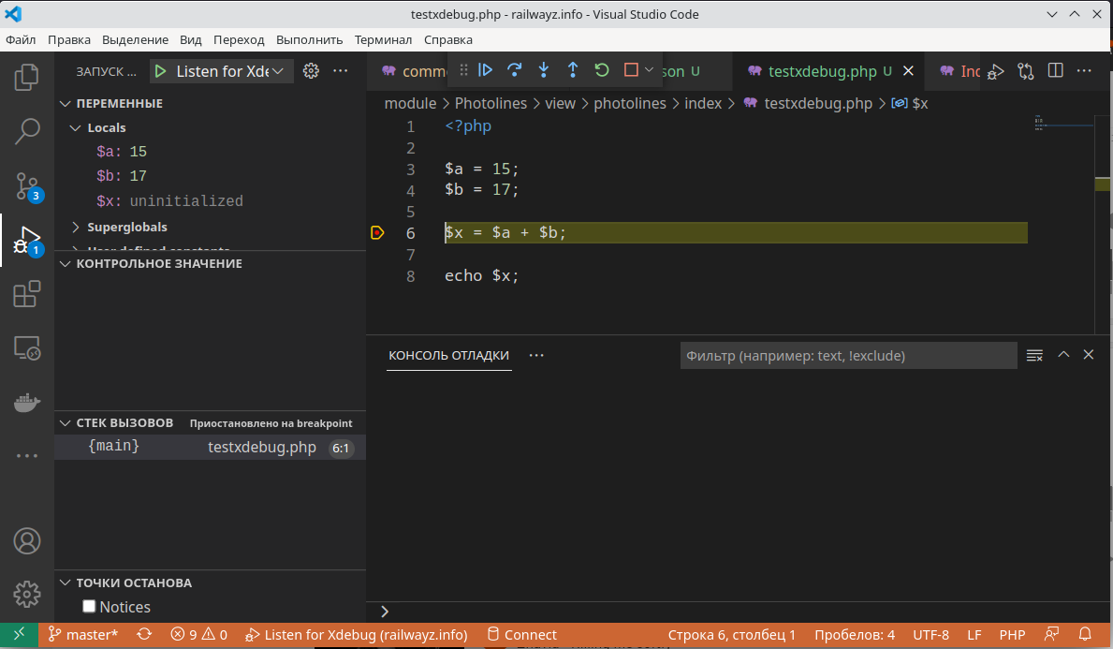

Debugging Web applications

1. Configure IDE

2. Use browser extension Xdebug helper

VSCode:

Ctrl-P, ext install xdebug.php-debug

Using Warning as breakpoint to debug

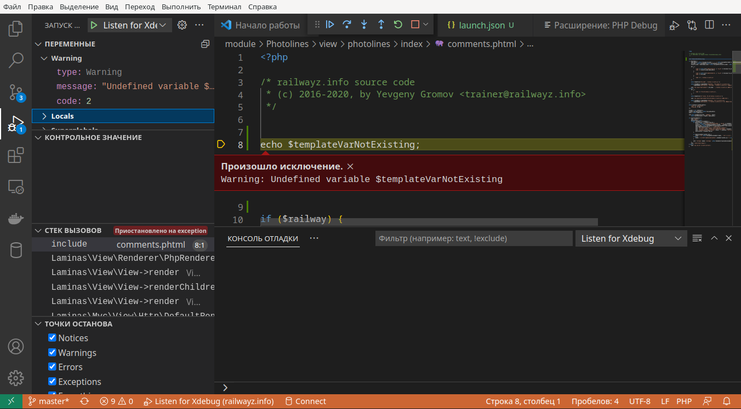

Using breakpoints

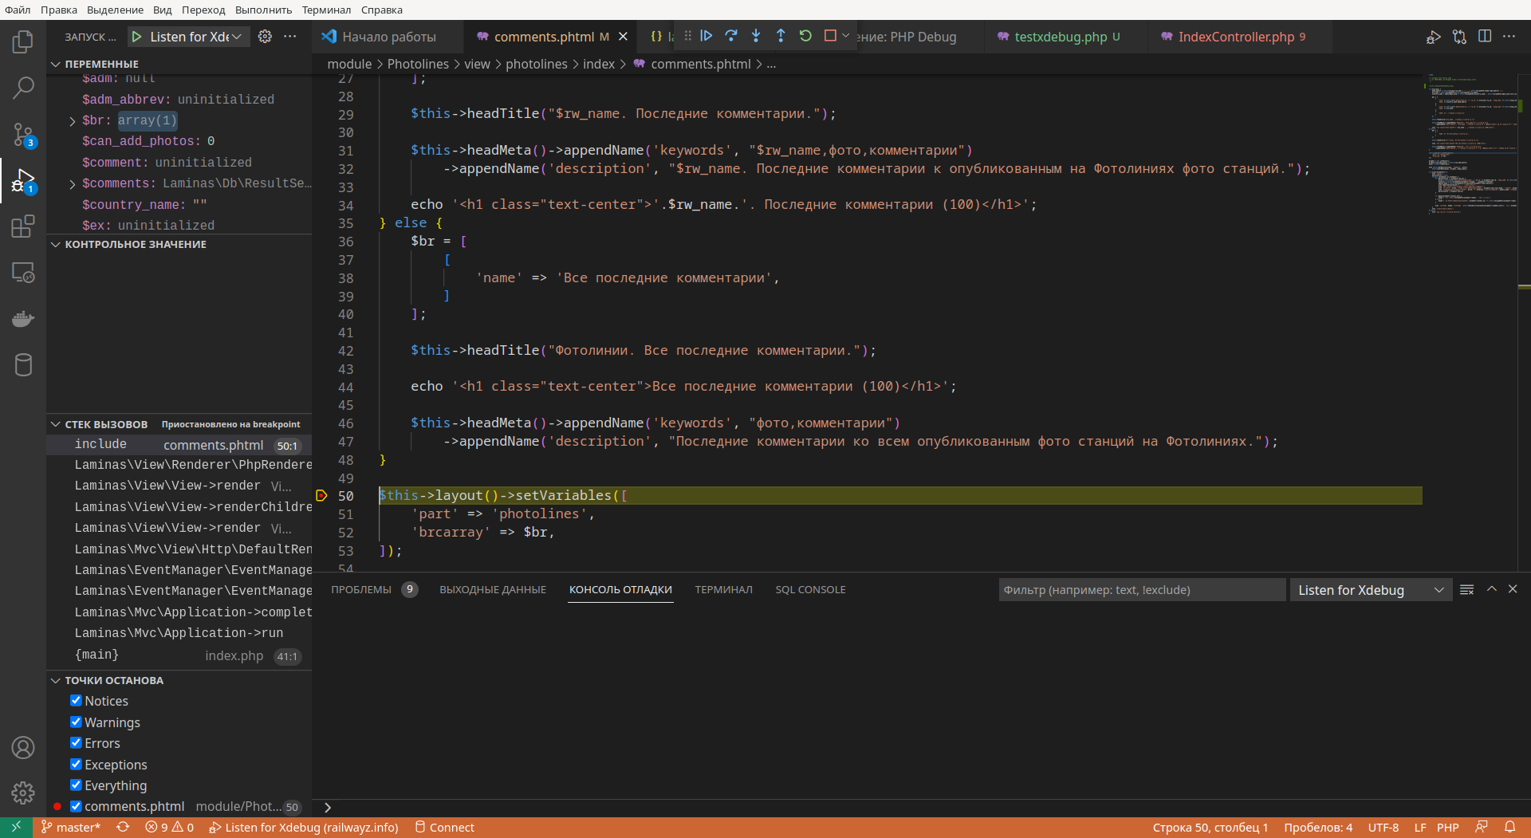

Improvements to PHP’s error reporting
Reporting without Xdebug
Warning: Undefined variable $templateVarNotExisting in /home/yevgeny/www/railwayz.info/module/Photolines/view/photolines/index/comments.phtml on line 8
Reporting with Xdebug error reporting enabled
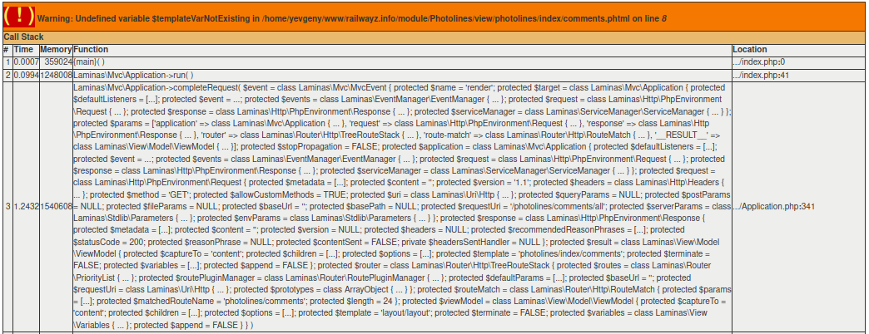

Function Trace
Xdebug allows you to log all function calls, including parameters and return values to a file in different formats.
Those so-called "function traces" can be a help for when you are new to an application or when you are trying to figure out what exactly is going on when your application is running. The function traces can optionally also show the values of variables passed to the functions and methods, and also return values. In the default traces those two elements are not available.

Output Formats #
There are three output formats. One is meant as a human readable trace, another one is more suited for computer programs as it is easier to parse, and the last one uses HTML for formatting the trace. You can switch between the different formats with the xdebug.trace_format setting. There are a few settings that control which information is written to the trace files. There are settings for including variable assignments (xdebug.collect_assignments) and for including return values (xdebug.collect_return) for example.

Profiling
Xdebug's built-in profiler allows you to find bottlenecks in your script and visualize those with an external tool such as KCacheGrind or WinCacheGrind.

Xdebug's Profiler is a powerful tool that gives you the ability to analyse your PHP code and determine bottlenecks or generally see which parts of your code are slow and could use a speed boost. The profiler also collects information about how much memory is being used, and which functions and methods increase memory usage.
The profiler in Xdebug outputs profiling information in the form of a Cachegrind compatible file. This allows you to use the excellent KCacheGrind tool (Linux, KDE) to analyse your profiling data. If you are on Linux you can install KCacheGrind with your favourite package manager.
If you are on Windows, there are precompiled QCacheGrind binaries available. (QCacheGrind is KCacheGrind without KDE bindings).
If you are on Mac OSX, homebrew has a formula for QCacheGrind.
There is also a web based front-end called Webgrind.
In case you can not use KDE (or do not want to use KDE) the kcachegrind package also comes with a perl script "ct_annotate" which produces ASCII output from the profiler trace files.

Code Coverage Analysis
Code coverage tells you which lines of script (or set of scripts) have been executed during a request. With this information you can for example find out how good your unit tests are.
Xdebug's code coverage functionality is often used in combination with PHP_CodeCoverage as part of PHPUnit runs. PHPUnit delegates the code coverage collection to Xdebug. It starts and stops code coverage through xdebug_start_code_coverage() and xdebug_stop_code_coverage() for every test, and uses xdebug_get_code_coverage() to retrieve the results.
Code coverage's main output is an array detailing which lines in which files have been "hit" while running the code with code coverage collection active. But the code coverage functionality can also, with an additional performance impact, analyse which lines of code have executable code on it, which lines of code can actually be hit (dead code analysis), and also can it do instrumentation to find out which branches and paths in functions and methods have been followed. The various options are documented with the xdebug_start_code_coverage() function.

